**Software Engineering G6046**

Record of a team meeting – template document (adapt as you see fit)

| **Team Number** | 1 |
| --- | --- |
| **Names of team members present** | 5 |
| **Meeting format** | Physical |
| **Date and time** | 12:00 PM - 30/01/2025 |
| **Meeting co-ordinator** | Henry |

1. **Matters to note from last meeting**

N/A - this is our first meeting.

1. **Issues discussed at this meeting**

Analysing which language to use.

discussing team roles and structure of sprints.

Creating a top down design of the overall structure of our program.

Agreeing on how to maintain consistency between developers on issues such as variable names, file locations.

1. **Decisions agreed at this meeting**

Language of choice: Python

TEAM ROLES:

* Callum Hemsley - Back end Developer
* Carys Flack - Front end Developer / design
* Henry Davies - Front end Developer / design
* Conor Lagden - Documentation + Testing
* Louis Henry - Documentation + Risk Analysis

Initial idea is to spend a week on sprints, and then a week on testing and documentation and adopt this week on / week off approach. This is amenable to change if these periods are too short.

We discussed maintenance of consistent variable names by storing them in a database. Using a database was discussed but this could warrant a technology risk since the system may not be able to process transactions fast enough since python is already a moderately slow language. A 2D array will be used instead. To add onto consistency, we will create a github page that all of us can access where code and files can be shared.

TOP DOWN DIAGRAM:

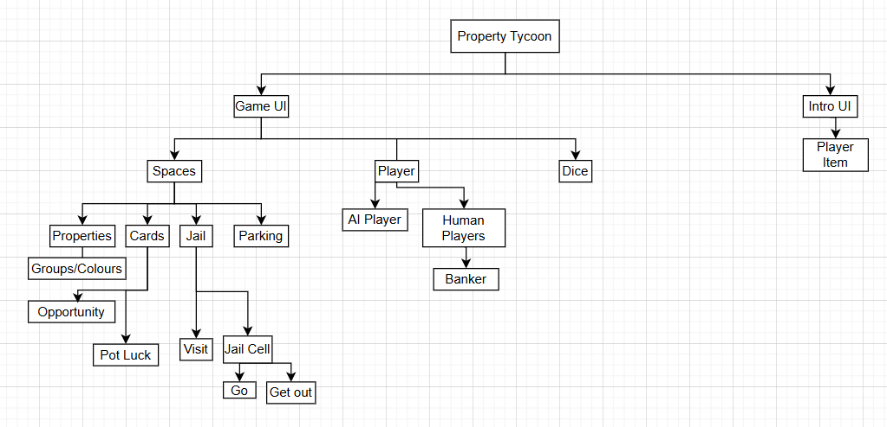

1. **Date of next meeting**

03/02/2025

**END**